

**Research & Vehicle Technology**

**“Infotainment Systems Product Development”**

**Feature – Digital A2B Audio Bus**

*Strawman for A2B SPSS for Phoenix Audio system.*

**Infotainment Subsystem Part Specific Specification (SPSS)**

Version 0.3 (DRAFT)

**UNCONTROLLED COPY IF PRINTED**

**Version Date: May 06, 2021**

**FORD CONFIDENTIALF**

*The information contained in this Specification is Confidential to Ford Motor Company.*

*Disclosure or distribution to unauthorized persons outside Ford Motor Company is strictly prohibited.*

**FORD CONFIDENTALF**

This Specification contains information developed and accumulated by and for FORD MOTOR COMPANY. As such, it is a confidential document, which, if disseminated outside the Company would provide others with restricted information, data, or procedures not otherwise available, exposing the Company to potential harm.

Employees having custody of this specification or authorized to use it must be cognizant of its confidential nature and ensure that the information herein is not made available to unauthorized persons.

FORD MOTOR COMPANY reserves the right to protect this work as an unpublished copyrighted work in the event of an inadvertent or deliberate unauthorized publication. FORD MOTOR COMPANY also reserves its rights under copyright laws to protect this work as a published work.

This specification or portions thereof shall not be distributed outside FORD MOTOR COMPANY or its designated supply base. Refer all questions concerning disclosure to the author(s) or to the Core Multimedia Engineering Department, Ford Motor Company.

**Specification Status: .**

* DRAFT status shall be used as a reference only, and does not imply it will match the released version. DRAFT status is the closest approximation of the released version at the time of approval.
* RELEASED status shall be used for designing for production.

**Table of Contents**

**Table of Contents** 3

# FRD-REQ-407092/A-Architectural Design

## Interface Requirements

### HW/SWR-REQ-407093/A-GPIO Signals

The module shall implement all General Purpose IO signal lines (GPIO) that are necessary for proper functionality as defined in the ADI *AD242x Data Sheet* or in the ADI *AD243x Data Sheet* – latest revision at time of sourcing. The logic values the GPIOs are set to shall be provided by Ford core engineering. The suppliers shall provide Ford with all intended uses of the ‘virtual GPIO’ registers.

See Analog Devices *AD242x Data Sheet* and *AD242x Programming Reference Manual,* or the *AD232x Data Sheet* and *AD243x Programming Reference Manual,* (dependent on supplier design) for pins on A2B micro for GPIO I/O.

#### HW/SWR-REQ-416431/A-Design guidelines for GPIO pins

The following charts identify the virtual GPIO (or GPIO Over Distance) pins each module shall use.

* “Resistor Pull down” (or P/D) lines are used for inputs.
* “Direct Micro Connect” (or D/C) lines are used for outputs.

|  |  |  |  |  |  |  |  |  |
| --- | --- | --- | --- | --- | --- | --- | --- | --- |
| AD2433 PIN | Pin Name | Alternative Function | Harman PAC Usage | Harman DSP AMP B&O 6 Usage | Harman DSP AMP B&O 10 Usage | Harman DSP AMP Revel 10 Usage | Harman DSP AMP Revel 24 Usage | GPIO Feature |
| 5 | SIO0 | PDM0 GPIO0 |  |  |  |  |  |  |
| 6 | SIO1 | PDW1 GPIO1 |  |  |  |  |  |  |
| 7 | SIO2 | ASPISS SPISSEL1 GPIO2 |  |  |  |  |  |  |
| 12 | SIO3 | GPIO3 |  |  |  |  |  |  |
| 13 | SIO4 | GPIO0 |  |  |  |  |  |  |
| 14 | GPIO7 | RRSTRB PDMCLK | IOD7DAT (GPIO7) (D/C) | IOD7DAT (GPIO7) (D/C) | IOD7DAT (GPIO7) (D/C) | IOD7DAT (GPIO7) (D/C) | IOD7DAT (GPIO7) (D/C) | Clip Detect |
| 15 | SDA | GPIO6 |  |  |  |  |  |  |
| 16 | SCL | GPIO5 |  |  |  |  |  |  |
| 17 | MISO | PWM1 GPIO5 | IOD0DAT (GPIO5) (D/C) | IOD0DAT (GPIO5) (D/C) | IOD0DAT (GPIO5) (D/C) | IOD0DAT (GPIO5) (D/C) | IOD0DAT (GPIO5) (D/C) | A2B Bus  Fully_Configured / Not_Configured |
| 18 | MOSI | PWM2 GPIO6 | IOD1DAT (GPIO6) (D/C) | IOD2DAT (GPIO6) (D/C) | IOD2DAT (GPIO6) (D/C) | IOD2DAT (GPIO6) (D/C) | IOD2DAT (GPIO6) (D/C) | Speaker Output  UnMuted / Muted |
| 19 | SCK | PWM3 GPIO0 | IOD3DAT (GPIO4) (P/D) | IOD3DAT (GPIO4) (P/D) | IOD3DAT (GPIO4) (P/D) | IOD3DAT (GPIO4) (P/D) | IOD3DAT (GPIO4) (P/D) | A2B Stream  Audio_Sent / Audio_Not_Sent |
| 22 | ADR1 | SPISS SPISSEL0 PWMOE CLKOUT GPIO4 |  |  |  |  |  |  |
| 23 | ADR2 | MCLK ASPISS SPISSEL2 CLKOUT GPIO4 |  |  |  |  |  |  |

|  |  |  |  |  |  |  |  |
| --- | --- | --- | --- | --- | --- | --- | --- |
| AD2433 PIN | Pin Name | Alternate Function | PDC Usage | Visteon PAC Usage | Visteon D245 Usage | China DuerOS Usage | GPIO Feature |
| 5 | SIO0 | PDM0 GPIO0 |  |  |  |  |  |
| 6 | SIO1 | PDW1 GPIO1 |  |  |  |  |  |
| 7 | SIO2 | ASPISS SPISSEL1 GPIO2 | IOD2DAT (GPIO2) (P/D) |  |  | IOD2DAT (GPIO2) (P/D) |  |
| 12 | SIO3 | GPIO3 |  |  |  |  |  |
| 13 | SIO4 | GPIO0 |  |  |  |  |  |
| 14 | GPIO7 | RRSTRB PDMCLK | N/C | IOD7DAT (GPIO7) (D/C) | IOD7DAT (GPIO7) (D/C) | IOD7DAT (GPIO7) (D/C) | Clip Detect |
| 15 | SDA | GPIO6 |  |  |  |  |  |
| 16 | SCL | GPIO5 |  |  |  |  |  |
| 17 | MISO | PWM1 GPIO5 | IOD0DAT (GPIO5) (P/D) | IOD0DAT (GPIO5) (D/C) | IOD0DAT (GPIO5) (D/C) | IOD0DAT (GPIO5) (D/C) | A2B Bus  Fully_Configured / Not_Configured |
| 18 | MOSI | PWM2 GPIO6 | IOD1DAT (GPIO6) (P/D) | IOD1DAT (GPIO6) (D/C) | IOD2DAT (GPIO6) (D/C) | IOD1DAT (GPIO6) (D/C) | Speaker Output  UnMuted / Muted |
| 19 | SCK | PWM3 GPIO0 | IOD3DAT (GPIO2) (D/C) | IOD3DAT (GPIO4) (P/D) | IOD3DAT (GPIO4) (P/D) | IOD3DAT (GPIO4) (P/D) | A2B Stream  Audio_Sent / Audio_Not_Sent |
| 22 | ADR1 | SPISS SPISSEL0 PWMOE CLKOUT GPIO4 |  |  |  |  |  |
| 23 | ADR2 | MCLK ASPISS SPISSEL2 CLKOUT GPIO4 |  |  |  |  |  |

#### HW/SWR-REQ-407094/A-GPIO0

This GPIO shall be used as a ‘Virtual GPIO’ as defined in the ADI *AD242x Data Sheet*, or in the ADI *AD243x Data Sheet.* The usage for this virtual GPIO is to be node specific and shall be defined in the *Phoenix Audio Peripheral Command and Control API Specification*.

**Message Type**: GPIO

|  |  |  |  |
| --- | --- | --- | --- |
| **Signal Name** | **Literals** | **Value** | **Description** |
| IO0 | Single Digit of Virtual GPIO - Logic ‘0’ | 0x0 | this is when IO0 is not asserted |
| Single Digit of Virtual GPIO - Logic ‘1’ | 0x1 | this is when IO0 is asserted |

#### HW/SWR-REQ-407095/A-GPIO1

This GPIO shall be used as a ‘Virtual GPIO’ as defined in the ADI *AD242x Data Sheet*, or in the ADI *AD243x Data Sheet.* The usage for this virtual GPIO is to be node specific and shall be defined in the *Phoenix Audio Peripheral Command and Control API Specification*.

**Message Type**: GPIO

|  |  |  |  |
| --- | --- | --- | --- |
| **Signal Name** | **Literals** | **Value** | **Description** |
| IO1 | Single Digit of Virtual GPIO - Logic ‘0’ | 0x0 | this is when IO1 is not asserted |
| Single Digit of Virtual GPIO - Logic ‘1’ | 0x1 | this is when IO1 is asserted |

#### HW/SWR-REQ-407096/A-GPIO2

This GPIO shall be used as a ‘Virtual GPIO’ as defined in the ADI *AD242x Data Sheet*, or in the ADI *AD243x Data Sheet.* The usage for this virtual GPIO is to be node specific and shall be defined in the *Phoenix Audio Peripheral Command and Control API Specification*.

**Message Type**: GPIO

|  |  |  |  |
| --- | --- | --- | --- |
| **Signal Name** | **Literals** | **Value** | **Description** |
| IO2 | Single Digit of Virtual GPIO - Logic ‘0’ | 0x0 | this is when IO2 is not asserted |
| Single Digit of Virtual GPIO - Logic ‘1’ | 0x1 | this is when IO2 is asserted |

#### HW/SWR-REQ-407097/A-GPIO3

This GPIO shall be used as a ‘Virtual GPIO’ as defined in the ADI *AD242x Data Sheet*, or in the ADI *AD243x Data Sheet.* The usage for this virtual GPIO is to be node specific and shall be defined in the *Phoenix Audio Peripheral Command and Control API Specification*.

**Message Type**: GPIO

|  |  |  |  |
| --- | --- | --- | --- |
| **Signal Name** | **Literals** | **Value** | **Description** |
| IO3 | Single Digit of Virtual GPIO - Logic ‘0’ | 0x0 | this is when IO3 is not asserted |
| Single Digit of Virtual GPIO - Logic ‘1’ | 0x1 | this is when IO3 is asserted |

#### HW/SWR-REQ-407098/A-GPIO4

This GPIO shall be used as a ‘Virtual GPIO’ as defined in the ADI *AD242x Data Sheet*, or in the ADI *AD243x Data Sheet.* The usage for this virtual GPIO is to be node specific and shall be defined in the *Phoenix Audio Peripheral Command and Control API Specification*.

**Message Type**: GPIO

|  |  |  |  |
| --- | --- | --- | --- |
| **Signal Name** | **Literals** | **Value** | **Description** |
| IO4 | Single Digit of Virtual GPIO - Logic ‘0’ | 0x0 | this is when IO4 is not asserted |
| Single Digit of Virtual GPIO - Logic ‘1’ | 0x1 | this is when IO4 is asserted |

#### HW/SWR-REQ-407099/A-GPIO5

This GPIO shall be used as a ‘Virtual GPIO’ as defined in the ADI *AD242x Data Sheet*, or in the ADI *AD243x Data Sheet.* The usage for this virtual GPIO is to be node specific and shall be defined in the *Phoenix Audio Peripheral Command and Control API Specification*.

**Message Type**: GPIO

|  |  |  |  |
| --- | --- | --- | --- |
| **Signal Name** | **Literals** | **Value** | **Description** |
| IO5 | Single Digit of Virtual GPIO - Logic ‘0’ | 0x0 | this is when IO5 is not asserted |
| Single Digit of Virtual GPIO - Logic ‘1’ | 0x1 | this is when IO5 is asserted |

#### HW/SWR-REQ-407100/A-GPIO6

This GPIO shall be used as a ‘Virtual GPIO’ as defined in the ADI *AD242x Data Sheet*, or in the ADI *AD243x Data Sheet.* The usage for this virtual GPIO is to be node specific and shall be defined in the *Phoenix Audio Peripheral Command and Control API Specification*.

**Message Type**: GPIO

|  |  |  |  |
| --- | --- | --- | --- |
| **Signal Name** | **Literals** | **Value** | **Description** |
| IO6 | Single Digit of Virtual GPIO - Logic ‘0’ | 0x0 | this is when IO6 is not asserted |
| Single Digit of Virtual GPIO - Logic ‘1’ | 0x1 | this is when IO6 is asserted |

#### HW/SWR-REQ-407101/A-GPIO7

This GPIO shall be used as a ‘GPIO Over Distance’ (or Hardwire GPIO) as defined in the ADI *AD242x Data Sheet*, or the ADI *AD243x Data Sheet.* The usage for this hardwire GPIO is to be reserved for audio clip detect events*.* The Main node shall directly connect the A2B IC GPIO7 pin to an Input pin on the DSP/Micro for real time processing. Amplifier Sub node shall directly connect the A2B IC GPIO7 pin to its internal clip detect circuit for real time processing. All other Sub nodes shall not use the ‘GPIO Over Distance’ feature for GPIO7.

**Message Type**: GPIO

A2B Audio Server asserts IO7 to tell the A2B Audio Client that a clip detect event has occurred.

|  |  |  |  |
| --- | --- | --- | --- |
| **Signal Name** | **Literals** | **Value** | **Description** |
| IO7 | No Clip Detect | 0x0 | this is when IO7 is not asserted |
| Clip Detect asserted | 0x1 | this is when IO7 is asserted |

### HW/SWR-REQ-407102/A-I2C Signals

#### HW/SWR-REQ-407103/A-I2C Command and Control

If the supplier chooses to use I2C, the supplier shall implement the I2C protocol and message set as defined in Phoenix Audio Peripheral Command and Control API Specification. This document defines the I2C and SPI communication protocol used to provide command and control using the A2B I2C/SPI backchannel.

### HW/SWR-REQ-407189/A-SPI Signals

#### HW/SWR-REQ-407190/A-SPI Command and Control

If the supplier chooses to use SPI, the supplier shall implement the SPI protocol and message set as defined in Phoenix Audio Peripheral Command and Control API Specification. This document defines the I2C and SPI communication protocol used to provide command and control using the A2B I2C/SPI backchannel.

### HW/SWR-REQ-407104/A-Clock Signals

#### HW/SWR-REQ-407105/A-Clock Signal Syncronization to A2B Streams

All Microphone signals and ‘Loopback’ signals on the A2B bus shall utilize the A2B Clock Pulse for analog to digital conversion, for transmission on the A2B bus, and for any intermediate/post processing of these signals.

## SWR-REQ-407106/A-Audio Client

The Audio Client is responsible for producing and transmitting the audio.

## SWR-REQ-407107/A-Audio Server

The Audio Server is responsible for receiving and sending the audio to speakers.

## A2B Audio Stream ID assignments

### SWR-REQ-407108/A-A2B Downstream Stream IDs

|  |  |  |  |  |  |
| --- | --- | --- | --- | --- | --- |
| **Stream Identifier** | **Audio Management SPSS** | **Stream Name** | **Sample Rate** | **Data Size** | **Slots Used** |
| Stream ID 1 |  | PAC Tuner Audio | 48 KHz | 24 bit | 1 |
| Stream ID 2 |  | PAC Tuner Audio | 48 KHz | 24 bit | 1 |
| Stream ID 3 |  | Android Audio Loopback | 48 KHz | 24 bit | 1 |
| Stream ID 4 |  | Android Audio Loopback | 48 KHz | 24 bit | 1 |
| Stream ID 5 |  | Android Audio Loopback | 48 KHz | 24 bit | 1 |
| Stream ID 6 |  | Android Audio Loopback | 48 KHz | 24 bit | 1 |
| Stream ID 7 |  | Premium Audio (Stereo) | 48 KHz | 24 bit | 1 |
| Stream ID 8 |  | Premium Audio (Stereo) | 48 KHz | 24 bit | 1 |
| Stream ID 9 |  | Premium Audio (Stereo) | 48 KHz | 24 bit | 1 |
| Stream ID 10 |  | Premium Audio (Stereo) | 48 KHz | 24 bit | 1 |
| Stream ID 11 |  | PAC Mic Input | 48 KHz | 24 bit | 1 |
| Stream ID 12 |  | PAC Mic Input | 48 KHz | 24 bit | 1 |
| Stream ID 13 |  | PAC Mic Input | 48 KHz | 24 bit | 1 |
| Stream ID 14 |  | PAC Mic Input | 48 KHz | 24 bit | 1 |
| Stream ID 15 |  | PAC Mic Input | 48 KHz | 24 bit | 1 |
| Stream ID 16 |  | PAC Mic Input | 48 KHz | 24 bit | 1 |
| Stream ID 17 |  | BT Audio Channels | 48 KHz | 24 bit | 1 |
| Stream ID 18 |  | BT Audio Channels | 48 KHz | 24 bit | 1 |
| Stream ID 19 |  | BT Audio Channels | 48 KHz | 24 bit | 1 |
| Stream ID 20 |  | BT Audio Channels | 48 KHz | 24 bit | 1 |
| Stream ID 21 |  | ICC LS-Channels | 48 KHz | 24 bit | 1 |
| Stream ID 22 |  | ICC LS-Channels | 48 KHz | 24 bit | 1 |
| Stream ID 23 |  | ICC LS-Channels | 48 KHz | 24 bit | 1 |
| Stream ID 24 |  | ICC LS-Channels | 48 KHz | 24 bit | 1 |

### SWR-REQ-407109/A-A2B Upstream Stream IDs

|  |  |  |  |  |  |
| --- | --- | --- | --- | --- | --- |
| **Stream Identifier** | **Audio Management SPSS** | **Stream Name** | **Sample Rate** | **Data Size** | **Slots Used** |
| Stream ID 50 | A2B-ID1 | PDC Main Cabin Audio - Left PDC MSS Driver Audio Mono/Phone | 48 KHz | 24 bit | 1 |
| Stream ID 51 | A2B-ID1 | PDC Main Cabin Audio - Right | 48 KHz | 24 bit | 1 |
| Stream ID 52 |  | Captains Announcement | 48 KHz | 24 bit | 1 |
| Stream ID 53 |  | AV Prompt | 48 KHz | 24 bit | 1 |
| Stream ID 54 |  | Ext Voice Call Audio | 48 KHz | 24 bit | 1 |
| Stream ID 55 |  | Phone - Receive Path | 48 KHz | 24 bit | 1 |
| Stream ID 56 |  | PDC AVAS Front/Rear | 48 KHz | 24 bit | 1 |
| Stream ID 57 | A2B-ID6 | Mix Pre-EQ Non Music | 48 KHz | 24 bit | 1 |
| Stream ID 58 | A2B-ID6 | Mix Pre-EQ Non Music | 48 KHz | 24 bit | 1 |
| Stream ID 59 | A2B-ID6 | Mix Pre-EQ Non Music | 48 KHz | 24 bit | 1 |
| Stream ID 60 | A2B-ID6 | Mix Pre-EQ Non Music | 48 KHz | 24 bit | 1 |
| Stream ID 61 |  | ANC+RNC (+ESE +EVSE) | 48 KHz | 24 bit | 1 |
| Stream ID 62 |  | ANC+RNC (+ESE +EVSE) | 48 KHz | 24 bit | 1 |
| Stream ID 63 |  | ANC+RNC (+ESE +EVSE) | 48 KHz | 24 bit | 1 |
| Stream ID 64 |  | ANC+RNC (+ESE +EVSE) | 48 KHz | 24 bit | 1 |
| Stream ID 65 |  | ANC+RNC (+ESE +EVSE) | 48 KHz | 24 bit | 1 |
| Stream ID 66 |  | ANC+RNC (+ESE +EVSE) | 48 KHz | 24 bit | 1 |
| Stream ID 67 | A2B-ID2 | PDC Aux Source MSS Zone 2 | 48 KHz | 24 bit | 1 |
| Stream ID 68 | A2B-ID3 | PDC Aux Source MSS Zone 3-6 | 48 KHz | 24 bit | 1 |
| Stream ID 69 | A2B-ID4 | PDC Target Prompt Driver | 48 KHz | 24 bit | 1 |
| Stream ID 70 | A2B-ID5 | PDC Target Prompt MSS Zone 2-6 | 48 KHz | 24 bit | 1 |
| Stream ID 71 |  | PAC Speaker Channels | 48 KHz | 24 bit | 1 |
| Stream ID 72 |  | PAC Speaker Channels | 48 KHz | 24 bit | 1 |
| Stream ID 73 |  | PAC Speaker Channels | 48 KHz | 24 bit | 1 |
| Stream ID 74 |  | PAC Speaker Channels | 48 KHz | 24 bit | 1 |
| Stream ID 75 |  | PAC Speaker Channels | 48 KHz | 24 bit | 1 |
| Stream ID 76 |  | PAC Speaker Channels | 48 KHz | 24 bit | 1 |
| Stream ID 77 |  | ICC Reference Channels | 48 KHz | 24 bit | 1 |
| Stream ID 78 |  | ICC Reference Channels | 48 KHz | 24 bit | 1 |
| Stream ID 79 |  | SSE Reference Channels | 48 KHz | 24 bit | 1 |
| Stream ID 80 |  | SSE Reference Channels | 48 KHz | 24 bit | 1 |
| Stream ID 81 |  | SSE Reference Channels | 48 KHz | 24 bit | 1 |
| Stream ID 82 |  | SSE Reference Channels | 48 KHz | 24 bit | 1 |
| Stream ID 83 |  | A2B Microphone Output | 48 KHz | 24 bit | 1 |
| Stream ID 84 |  | A2B Microphone Output | 48 KHz | 24 bit | 1 |
| Stream ID 85 |  | A2B Microphone Output | 48 KHz | 24 bit | 1 |
| Stream ID 86 |  | A2B Microphone Output | 48 KHz | 24 bit | 1 |

## A2B Architectures

### SWR-REQ-407110/A-A2B Architectures

The following are the planned multimedia system architectures. These architectures shall be managed via Ford End-Of-Line diagnostic configuration.

(tbd)

#### SWR-REQ-407111/A-Phoenix Audio with 2 Nodes - Non-Branded

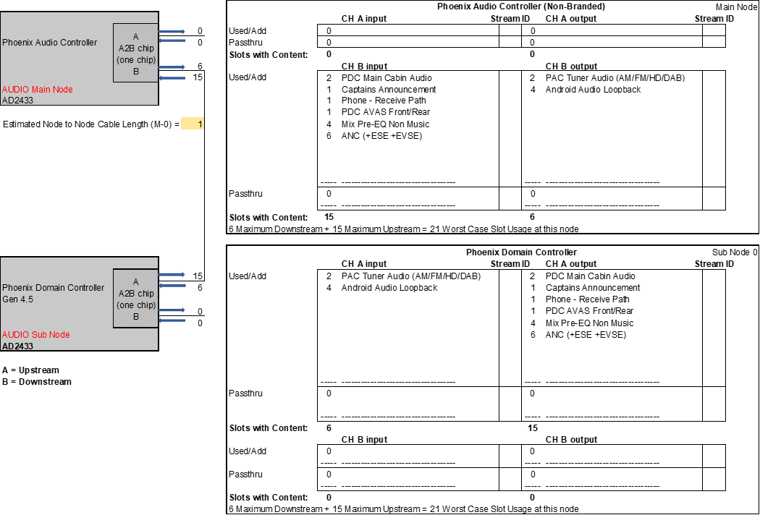

#### SWR-REQ-407112/A-Phoenix Audio with 3 Nodes - Non-Branded

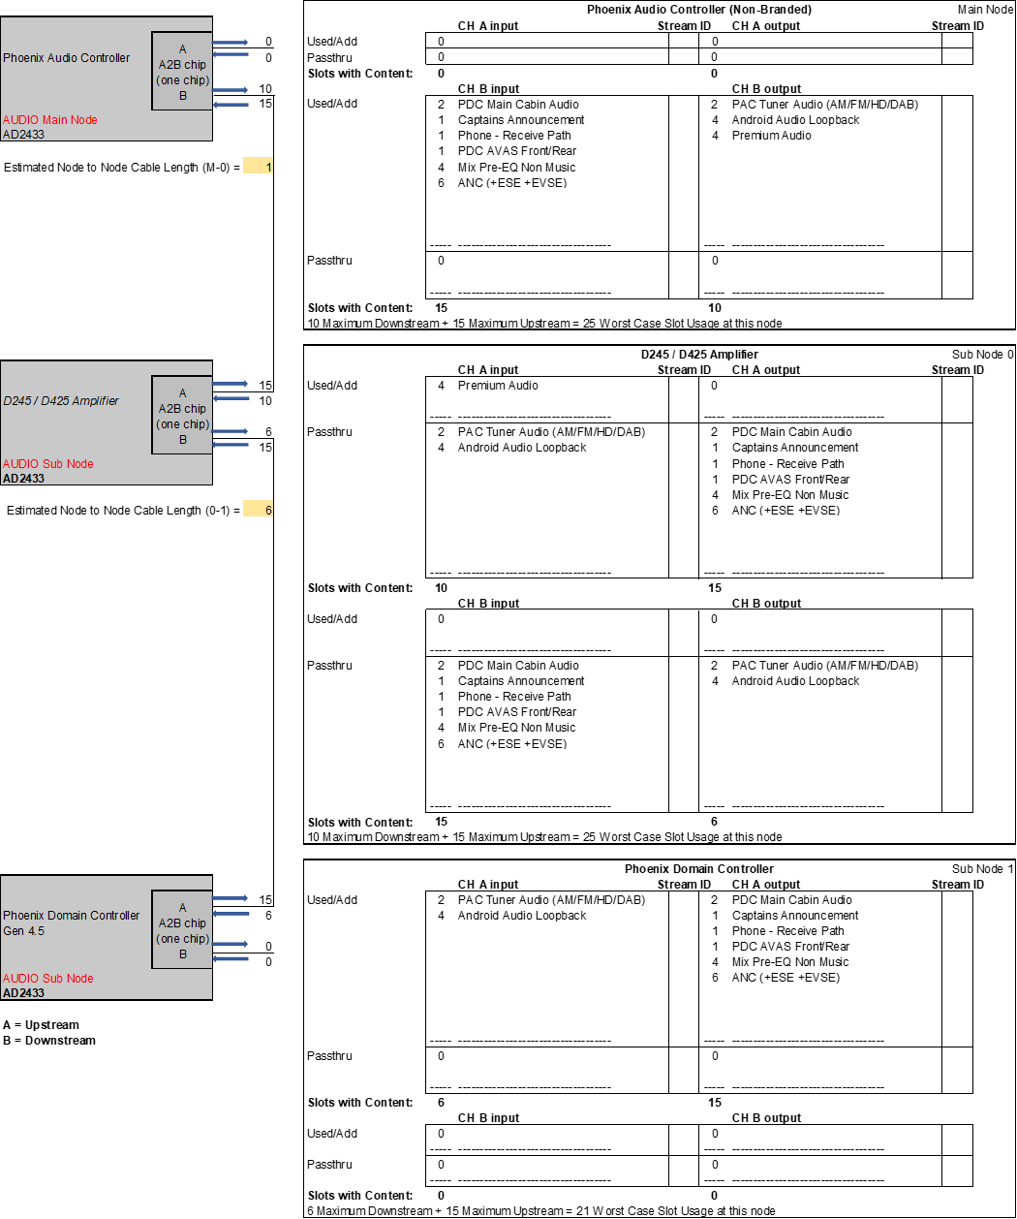

#### SWR-REQ-407113/A-Phoenix Audio with 2 Nodes - Branded

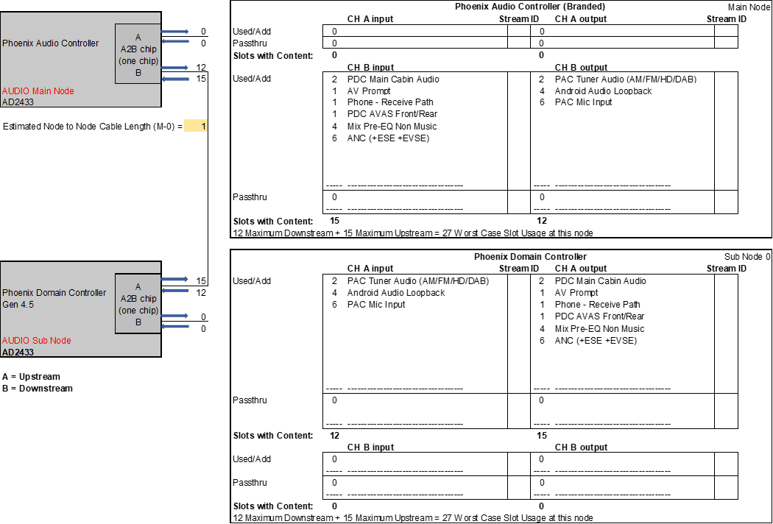

#### SWR-REQ-407114/A-Phoenix Audio with 3 Nodes - Branded PAC 2-3-4-5

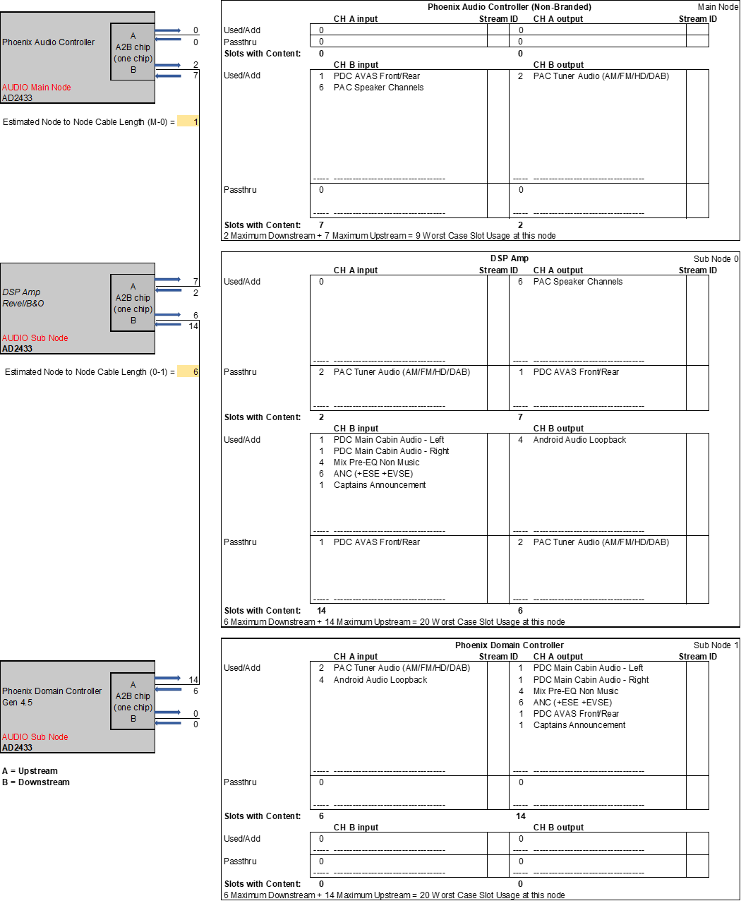

#### SWR-REQ-416750/A-Phoenix Audio with 3 Nodes - Branded PAC 6-7-8



#### SWR-REQ-416751/A-Phoenix Audio with 3 Nodes - Branded PAC 9-10-11



#### SWR-REQ-407115/A-Phoenix Audio with 2 Nodes - DuerOS - Subwoofer_Base

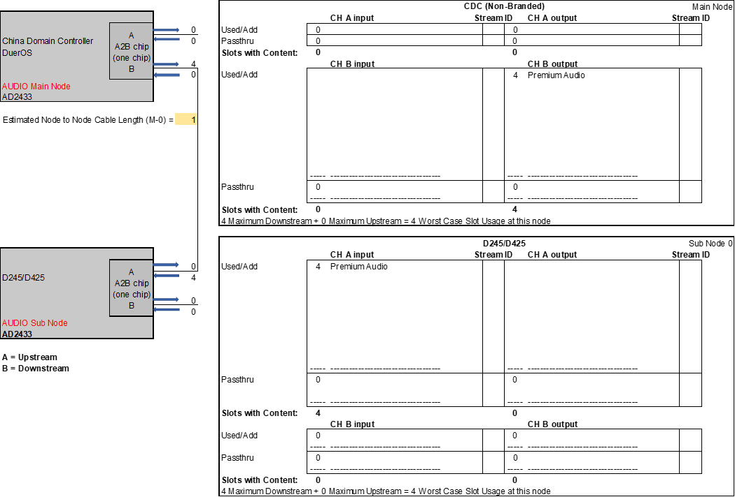

#### SWR-REQ-410563/A-Phoenix Audio with 2 Nodes - DuerOS - w/o ICC and w/o MSS

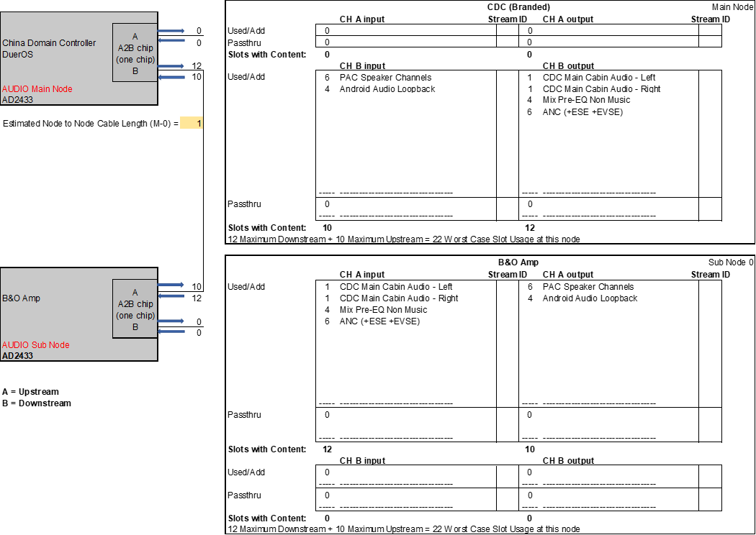

#### SWR-REQ-416752/A-Phoenix Audio with 3 Nodes - DuerOS - w/ ICC and w/o MSS



#### SWR-REQ-416753/A-Phoenix Audio with 3 Nodes - DuerOS - w/ ICC and w/ MSS

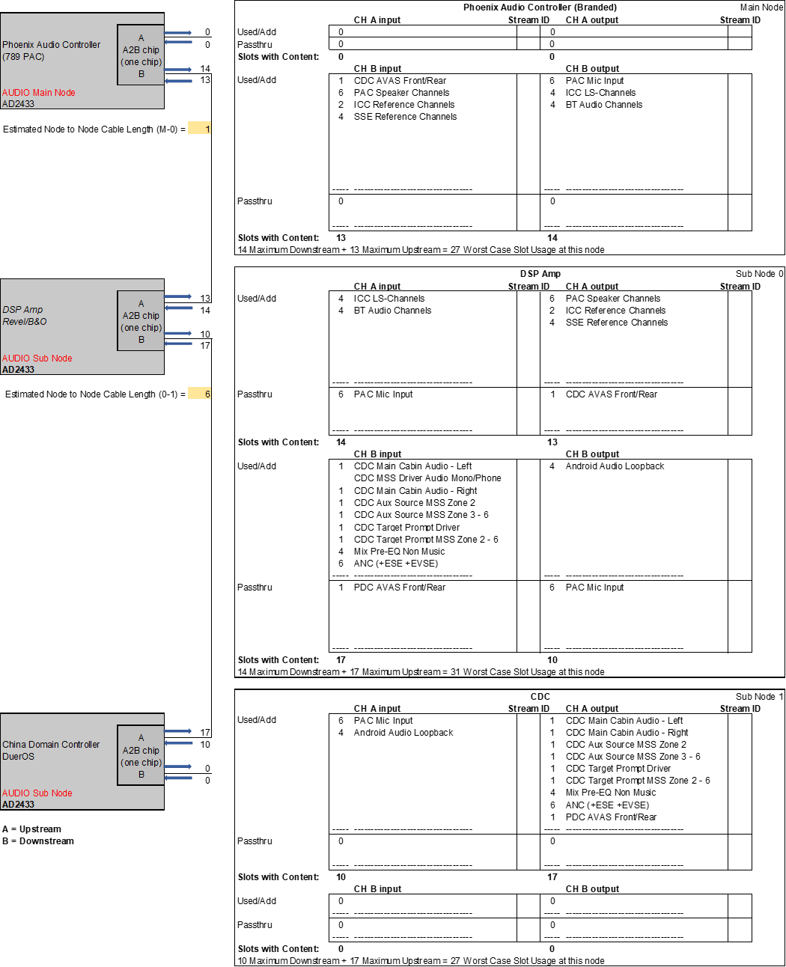

# FRD-REQ-407128/A-General Requirements

## SWR-REQ-407129/A-A2B ADI Stack Software

The A2B Main supplier shall integrate the *ADI A2B Software Stack* “ADI_A2B_Software_Rel19.0.0” or later on their µC/DSP to interface with the A2B Main IC and network. The supplier shall reference and comply with the latest version of ADI’s *A2B Stack User Guide* revision 6.0 or later as part of the release package.

## HW/SWR-REQ-414938/A-A2B Audio Bus Start-up and Shut Down

**A2B Digital Audio Bus Start-Up:**

The A2B Digital Audio Bus shall initialize and become active & functional when the CAN bus is active. Reference “Analog Devices A2B Link Implementation Specification” for details and A2B start-up times.

At A2B bus start-up, the virtual GPIO (or GPIO over Distance) registers and hardwired GPIOs (Direct Micro Connect) shall initialize to all zero’s:

* IOD0DAT@ PAC = 0x0 Not_Configured

(PAC sets this register for all modules on the bus via GPIO over Distance)

* IOD1DAT@ PAC = 0x0 Muted

(PAC sets this register for PAC and PDC via GPIO over Distance)

* IOD2DAT@ AMP = 0x0 Muted

(AMP sets this register for AMP and PDC via GPIO over Distance)

* IOD3DAT@ PDC = 0x0 Audio_Not_Sent

(PDC sets this register for all modules on the bus via GPIO over Distance)

* Direct Micro Connect lines identified in *HW/SWR-REQ-416431-Design guidelines for GPIO pins*

All modules shall send muted data over A2B (ex: volume step 0) while the A2B digital audio bus is active and the modules are not ready to play audio (i.e. muted data while HMIAudioMode = OFF (infotainment system OFF) and Power_Up_Chime_Module = Inactive (Infotainment Chimes and Chime Diagnostics not active), or modules are not powered up).

All speaker outputs on all the modules shall be muted until the below conditions are met.

**PAC’s IOD0DAT register usage**:

The A2B Main Node (PAC) asserts IOD0DAT when the A2B bus is fully initialized and all sub node registers are fully configured (i.e. IOD0DAT = Fully_Configured).

**PAC’s IOD1DAT register usage:**

The PAC shall set it’s IOD1DAT to “UnMuted” when:

* the PAC is ready to receive audio (ex. PAC has unmuted its internal amplifier IC’s for the PAC speakers and can receive audio without producing pops) and the A2B bus is initialized

The PAC shall set it’s IOD1DAT from “Muted” to “UnMuted” within 950 msec of:

* (HMIAudioMode changing from OFF/Load Shed to ON, OR Power_Up_Chime_Modules changing from Inactive to Active)

After the PAC asserts it’s IOD1DAT = “UnMuted” the PAC shall keep it’s IOD1DAT = “UnMuted” whenever HMIAudioMode = ON or Power_Up_Chime_Modules = ON unless an error condition occurs (such as a reset of the A2B digital audio bus).

Note: Crank is not considered an error condition and so the IOD1DAT interface is not used for Crank muting/unmuting. Ex. If IOD1DAT = “UnMuted” before crank and infotainment system is ON then the PAC would keep it’s IOD1DAT = “UnMuted” during crank.

If an EVCM is present, the PAC external speakers may unmute faster than what is defined in this document.

**AMP’s IOD1DAT register usage:**

The AMP shall set it’s IOD2DAT to “UnMuted” when:

* the AMP is ready to receive audio (ex. AMP has unmuted its internal amplifier IC’s for the AMP speakers and can receive audio without producing pops), the AMP is ready to transmit audio (ex. can transmit audio to the PAC without producing pops), and the A2B bus is initialized

The AMP shall set it’s IOD2DAT from “Muted” to “UnMuted” within 950 msec of:

* (HMIAudioMode changing from OFF/Load Shed to ON, OR Power_Up_Chime_Modules changing from Inactive to Active)

After the AMP asserts it’s IOD2DAT = “UnMuted” the AMP shall keep it’s IOD2DAT = “UnMuted” whenever HMIAudioMode = ON or Power_Up_Chime_Modules = ON unless an error condition occurs (such as a reset of the A2B digital audio bus).

Note: Crank is not considered an error condition and so the IOD2DAT interface is not used for Crank muting/unmuting. Ex. If IOD2DAT = “UnMuted” before crank and infotainment system is ON then the AMP would keep it’s IOD2DAT = “UnMuted” during crank.

If an amplifier is used that is not connected to the HS-Can line, then:

The AMP shall set it’s IOD2DAT from “Muted” to “UnMuted” within 950 msec of IOD0DAT going from “Not_Configured” to “Fully_Configured”.

After the AMP asserts it’s IOD2DAT = “UnMuted” the AMP shall keep it’s IOD2DAT = “UnMuted” whenever IOD0DAT is “Fully_Configured” unless an error condition occurs (such as a reset of the A2B digital audio bus).

**PDC’s IOD2DAT register usage:**

The PDC shall set the IOD3DAT in the PAC and in the AMP to “Audio_Sent” when it is ready to transmit audio (ex. PDC has received PAC’s IOD1DAT = “UnMute” and the AMP’s IOD2DAT = “UnMute” and can transmit audio without producing pops).

The PDC shall set IOD3DAT from “Audio_Not_Sent” to “Audio_Sent” within 950 msec of:

* HMIAudioMode changing from OFF/Load Shed to ON, **OR**
* Power_Up_Chime_Modules changing from Inactive to Active

BUT not before:

* PAC’s IOD1DAT = “UnMute”, **AND**
* AMP’s IOD2DAT = “UnMute”

Note: if PDC receives:

* PAC’s IOD1DAT = “UnMute”, **AND**
* AMP’s IOD2DAT = “UnMute”

at greater than or equal to 920 msec after:

* HMIAudioMode turned to ON, **OR**
* Power_Up_Chime_Module = Active

then, the PDC shall set the

* PAC’s IOD3DAT = “Audio_Sent”, **AND**
* AMP’s IOD3DAT = “Audio_Sent”

within 30 msec.

After the PDC asserts IOD3DAT = “Audio Sent” the PDC shall keep the IOD3DAT = “Audio_Sent” whenever HMIAudioMode = ON or Power_Up_Chime_Modules = ON unless an error condition occurs (such as a reset of the A2B digital audio bus).

Note: Crank is not considered an error condition and so the IOD3DAT interface is not used for Crank muting/unmuting. Ex. If the IOD3DAT = “Audio_Sent” before crank and infotainment system is ON then the PDC would keep the IOD3DAT = “Audio_Sent” during crank.

PAC response to setting IOD1DAT:

The PAC shall:

* keep its internal amplifier IC’s in a ‘pop free’ state after the PAC sets it’s IOD1DAT = “UnMuted”, **AND**
* send muted audio data to the PDC over the A2B digital audio bus until after the PDC asserts and keeps asserted the IOD3DAT = “Audio_Sent”.

AMP response to setting IOD2DAT:

The AMP shall:

* keep its internal amplifier IC’s in a in a ‘pop free’ state after the AMP sets it’s IOD2DAT = “UnMuted” , **AND**
* send muted audio data to the PDC over the A2B digital audio bus until after the PDC asserts and keeps asserted the IOD3DAT = “Audio_Sent”, **AND**
* send muted audio data to the PAC over the A2B digital audio bus until after the PDC asserts and keeps asserted the IOD3DAT = “Audio_Sent”.

PDC response to IOD1DAT from the PAC and IOD2DAT from the AMP:

The PAC shall:

* transmit muted audio data for all A2B streams to the PAC and the AMP until after A2B bus is initialized, **AND**
* transmit muted audio data for all A2B streams to the PAC and the AMP until after BOTH the AMP asserts and keeps asserted it’s IOD2DAT = “UnMuted” AND the PAC asserts and keeps asserted it’s IOD1DAT = “UnMuted”.
* After both IOD1DAT and IOD2DAT are asserted AND IOD3DAT is asserted, then audio data shall be sent over A2B digital audio bus.

Sequence Diagram Example (Speakers out of PAC and AMP):

T_A2B_InitComplete see “A2B link implementation specification”.

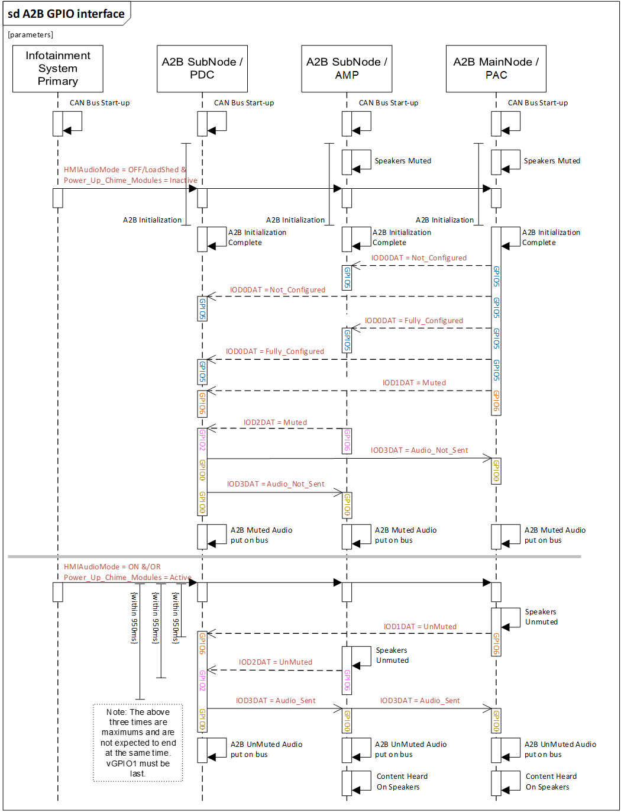

**Infotainment Shutdown Shut-Down while A2B digital audio bus active:**

The infotainment system shall follow the shutdown process called out in the Station Management SPSS.

When HMIAudioMode = OFF and Power_Up_Chime_Modules = Inactive, then within 30ms:

* The PDC and the AMP shall gracefully send muted data over A2B if the A2B digital audio bus is still active
* The PAC and AMP (if PAC and AMP both have speakers) shall gracefully mute its speaker outputs.

After muting the outputs, the following Virtual GPIO signals shall be set:

* PAC’s IOD1DAT = “Muted”
* AMP’s IOD2DAT = “Muted”
* PDC’s IOD3DAT = “Audio_Not_Sent”

Note: If an EVCM is present, the PAC muting strategy for the EVCM external speakers shall follow the Power Mode SPSS process.

## A2B Discovery Configuration

### SWR-REQ-407130/A-Initial A2B Discovery Precursors - Main Node

The A2B Main node shall:

* Utilize the latest version of ADI Sigma Studio software (or equivalent) at the time of sourcing, minimum revision of 3.15.
* Perform a runtime discovery of the A2B devices connected to the network as specified in the “*Analog Devices A2B Link Implementation Specification*”.
* Implement the latest version of ADI A2B Software Stack (or equivalent) at time of sourcing, minimum revision of 17.0.0.
* Follow the ‘Simple Discovery Flow’ as defined in Sigma Studio.
* Enable the A2B Bus Monitor Mode feature by enabling the ‘ENDSNIFF’ (0x20) bit on the Main DATCTL register. This bit shall be configurable On/Off.

### SWR-REQ-407131/A-Initial A2B Discovery Precursors - Sub Node

The A2B Sub node shall:

* Store a unique identifier in the modules memory. If the module has no Microprocessor (ie: a Sub I2C device), a EEPROM with minimum of 256 bytes shall be implemented. The EEPROM shall be set to an I2C address of 0xA0.The Main Node shall directly access the EEPROM to read the Node Identifier.
* Utilize the latest version of ADI Sigma Studio software (or equivalent) at the time of sourcing, minimum revision of 3.15.
* Utilize Sigma Studio (or equivalent) to identify the register settings required for the proper operation of their node on the A2B bus, and send the verified exported ‘NCF.xml’ node configuration file to Ford Core Multimedia Engineer.
* Implement the ‘Custom Node Identifier’ field within the ‘NCF.xml’ file. The ‘Custom Node Identifier’ values shall be as follows:

### SWR-REQ-407132/A-Table of Custom Node Identifiers

|  |  |  |  |
| --- | --- | --- | --- |
| **Sub Node** | **Custom Node Identifier** | | |
| **Type** | **Location that Node ID is at** | **Node Value** |
| **Type** |
| D245 2 Channel Amp | I2C Device | Defined in ‘NCF.xml’ file | 0x01 |
| D425 4 Channel Amp | I2C Device | Defined in ‘NCF.xml’ file | 0x02 |
| B&O Amp – 6 Channel | I2C Device | Defined in ‘NCF.xml’ file | 0x83 |
| B&O Amp – 10 Channel | I2C Device | Defined in ‘NCF.xml’ file | 0x84 |
| Revel Amp – 12 Channel | I2C Device | Defined in ‘NCF.xml’ file | 0x85 |
| Revel Amp – 24 Channel | I2C Device | Defined in ‘NCF.xml’ file | 0x86 |
| Phoenix Domain Controller | I2C Device | Defined in ‘NCF.xml’ file | 0x07 |
| A2B Microphone | I2C Device | Defined in ‘NCF.xml’ file | 0x08 |

* Allow the A2B Main node to set up all Sub node A2B register values.
* The node variant shall be made available using a separate A2B I2C/SPI message.

Note: It is permitted to have two identical sub nodes in the same vehicle A2B bus configuration file setup with the same custom node identifier information. The two sub node’s hardware and software MUST be completely identical for this to be true.

### SWR-REQ-407133/A-Generic A2B Sub Node Discovery Process

This flow chart describes Custom Node ID Authentication process during discovery of an A2B sub node.

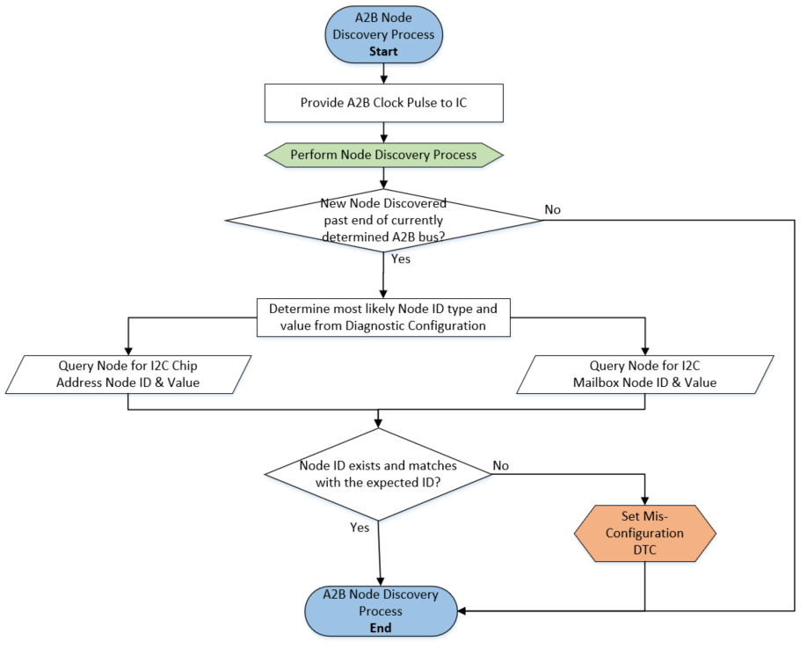

The ‘Node Discovery Process’ follows the ‘Simple Discovery Flow’ as described in ‘AD242x A2B Transceiver Programming Reference Manual’ or the ‘AD243x A2B Transceiver Programming Reference Manual’.

### SWR-REQ-407135/A-Generic A2B Software Update Process

This flow chart describes the process of updating an individual node’s software. The A2B bus has already been discovered, all nodes identified, and has been configured for use. The Main Node shall determine if a software update is needed by performing a software version request per *Phoenix Audio Peripheral Command and Control API Specification: SWR-REQ-335615-General Get Versions* and confirming if the *SoftwareVersion* value sent by the node matches the *SoftwareVersion* value contained in the A2B Main’s Sub node software repository. The software file structure is defined in *Software Update File Structure*.



## SWR-REQ-407139/A-A2B B&A Plant EOL configuration

The A2B main node shall have a configuration that allows each possible bus configuration to be selectable.

## Error Handling

### SWR-REQ-407140/A-Loss of Communication with Main Node A2B IC

When the Main Node identifies I2C/SPI communication loss due to loss of Audio Clock, Loss of Power to the A2B IC, or loss of Main Node A2B register configurations, then the Main Node shall:

* perform a periodic rediscovery of the A2B bus every 1 second
* set the appropriate DTC per the Infotainment Diagnostics Specification.

If the Vehicle Multimedia Architecture includes an external branded amplifier, then when the above condition occurs, the Main Node shall also do the following:

* perform a soft mute of the Audio server(s)
* set the signal InfotainmentAudio.St = ErrorState_NoAudio
* set Chime_Supported = Not Supported returning chime control back to the Cluster.

Note1: reference the Clock and Reset Timing table in the *AD242x Data Sheet* or the *AD243x Data Sheet* specification for details on clock and reset parameters. The flags TNSCFR and TNSYNCR are defined in the *AD242x Data Sheet* or the *AD243x Data Sheet* specification.

Note2: reference the *Analog Devices A2B Data link Implementation Specification* for clock reset details.

Some occurrences of when the clock signal is considered lost:

- When the A2B Sub chip (ex A2B chip in DSP AMP) detects loss of Main A2B clock signal for TNSCFR then the clock is considered lost. If there is any contradiction between the SPSS definition of A2B Sub chip clock lost and the *Analog Devices A2B Data link Implementation Specification* definition of Sub chip clock lost, then the *Analog Devices A2B Data link Implementation Specification* shall take precedent.

OR

- Additional instances and details for when the clock is considered lost reference *AD242x Data Sheet* or the *AD243x Data Sheet* specification and the *Analog Devices A2B Data link Implementation Specification.*

### SWR-REQ-407141/A-Line Fault Handling Process

The Main node shall utilize the ‘line fault diagnostics’ feature with ‘fault localization’ to monitor the A2B bus for faults, and to identify localized fault types (short to ground, short to battery, shorted together, or lines reversed). The retry strategy for identified faults shall be to attempt to rediscover the A2B bus every 500ms until the fault condition is no longer present.

This digital interface shall adhere with the standard Ford diagnostics “*IDS Spec*” and must be capable to detect and survive indefinite short circuits (Zsc < 350[mΩ]) to ground or battery. Once a short circuit occurs and is removed, the output shall return to its normal state as stated in *Analog Devices A2B Data link Implementation Specification*.

If the line fault diagnostics feature has detected an A2B Bus fault as listed above for 5 seconds or more while the infotainment system is on (HMIAudioMode = ON) or while chimes is active (Power_Up_Chime_Modules = Active) then the Audio Client and the A2B Main node shall take the following actions:

* The Audio Client shall notify the A2B Main Node when this occurs and when it recovers.
* The A2B Main node shall set Chime_Supported = Not Supported returning chime control back to the Cluster.
* The A2B Main node shall change the InfotainmentAudio.St signal from “NormalOperation” to “ErrorState_NoAudio”.
* The A2B Main Node shall set a DTC as defined in the Infotainment Diagnostics Specification.

A2B digital audio bus recovers:

* When the A2B bus recovers, it shall follow the normal A2B audio start-up process.
* The A2B Main node shall set the signal InfotainmentAudio.St = NormalOperation

### SWR-REQ-407142/A-Loss of Communication with Amplifier Sub Node

While the infotainment system is in normal operation:

* Power_Up_Chime_Modules = Active and/or HMIAudioMode = ON

If either the Audio Client or the Audio Server detects they are unable to transmit/receive/amplify chime content due to any reason for more than 5 seconds, then:

- The Audio Server shall notify the A2B Main node that chimes are not supported.

- The A2B Main node shall set Chime_Supported = Not Supported returning chime control back to the Cluster.

- The A2B Main node shall change the InfotainmentAudio.St signal from “NormalOperation” to “ErrorState_NoAudio”.

### SWR-REQ-407143/A-Retrying handling at A2B bus initialization

See *Analog Devices A2B Data link Implementation Specification* for retry handling.

### SWR-REQ-407144/A-Wrong Configuration at EOL

See *Analog Devices A2B Data link Implementation Specification* for A2B EOL error configuration handling.

The A2B Main node shall set the appropriate diagnostics error code (see *Infotainment Diagnostics Specification)*.

The A2B Main Node shall record the ‘alternate’ matching configuration in a Diagnostic DID.

### SWR-REQ-407146/A-Data Error Handling Process

The Main node shall monitor the A2B communication for the following data bit errors:

* Header Count Error (HDCNTERR)
* Data Decode Error (DDERR)
* (CRCERR)
* Parity Errors (DPERR)
* Bit Errors (BECOVF)
* (SRFERR)
* SRFCRCERR (sub node only)

The Main Node shall adhere with Ford diagnostics *Infotainment Diagnostics Specification* with respect to A2B Bit Error faults.

### SWR-REQ-407147/A-Sub Node Power Loss Fault Handling Process

If the Sub node’s A2B transceiver unexpectedly shuts down, the Sub node shall record that the event occurred in non-volatile memory. Once the Sub node’s A2B transceiver starts responding again, the Sub node shall return to its normal state and wait to be rediscovered.

## Audio Content Management

### SWR-REQ-407148/A-Audio Server side Initialized

The Audio Server shall not process any Audio content received on any A2B stream until the receiving circuitry has stabilized. (ie: the A2B audio content shall be ignored until the amplifiers are stabilized and pop-free)

### SWR-REQ-407149/A-Audio Client side Initialized

The Audio Client shall transmit full mute on all A2B Audio Streams until the transmitting circuitry has stabilized. (ie: the A2B Tuner Audio stream shall send audio content of ‘full mute’ until the tuner circuitry is fully initialized and stable)

### SWR-REQ-407150/A-Audio Client side De-Allocated

The Audio Client shall transmit full mute on all A2B Audio Streams not in use. (ie: A2B Streams ‘PAC Speaker Channels’ shall transmit full mute when the Audio HMI is turned off by the customer, and no other audio source is playing such as a phone call or Navigation prompt.)

This supersedes SPSS requirement “AUMGNT-GREQ-220856-Muting and Unmuting of Audio Resource Server Line Level signal to the external DSP AMP for source changes” which is for when there is not a digital audio bus connection.

### SWR-REQ-407151/A-Audio Server side Audio Quality

The Audio Server shall play audio:

* Without any distortions caused by the Digital Audio Transport signal.
* With no choppy data from digital audio data getting buffered.
* With the latencies from when the audio signal leaves the Audio Client until the audio is output from the Audio Server being no worse than if analog signals were used.
* With the audio quality being as good or better than analog:
  + S/N ratio (ex. can’t hear digital noise, clock jitter when there is no volume or low volume)
  + Non-corrupted data
  + Digital Bit Stream for test signal looks better than analog signal test signal

## SWR-REQ-407152/A-Audio Performance during a Start-Stop Event

The A2B bus shall be independent of any Start-Stop event. It shall continue to function during a ‘warm crank’ event per *SWR-REQ-348828-Audio Server side Audio Quality*.

## SWR-REQ-407153/A-Audio Performance during a Thermal Reduction Event

The A2B bus shall be independent of any Thermal Reduction event. It shall continue to function during a Thermal Reduction event per *SWR-REQ-348828-Audio Server side Audio Quality*.

# FRD-REQ-407154/A-Functional Definition

## A2B Use Cases

### Sub Node Discovery Use Cases

#### UC-REQ-407155/A-Generic A2B Bus Configuration Process

|  |  |
| --- | --- |
| **Actors** | A2B Main Node, Multiple A2B Sub Nodes |
| **Pre-conditions** | * Sub modules are connected on the A2B bus * Main node has been configured for A2B node order. |
| **Scenario Description** | * Main node reads Diagnostic Configuration and identifies appropriate sequence of Sub nodes on A2B bus * A2B Node Discovery process performed * Sequence of A2B nodes identified matches configuration. * A2B register settings are sent to all nodes for EOL configured bus structure |
| **Post-conditions** | A2B bus discovery complete. |
| **List of Exception Use Cases** | 1. Sub node sequence from Node Discovery Process does not match EOL configuration.   Action: Set DTC for A2B bus misconfiguration |
| **Interfaces** |  |

#### UC-REQ-407157/A-A2B Sub Node Discovery Process for Mailbox I2C/SPI Communication

|  |  |
| --- | --- |
| **Actors** | Main Node, Multiple A2B Sub Nodes |
| **Pre-conditions** | * Main node is present on the A2B bus * Sub modules are interconnected on the A2B bus in specific order * Sub Node Discovery Process underway, and Sub node with I2C microcontroller is the next node to be discovered |
| **Scenario Description** | Main node requests Sub Node ID |
| **Post-conditions** | Main node reads Sub node’s mailbox for Sub Node ID |
| **List of Exception Use Cases** | 1. Sub Node ID is not placed in Sub node’s mailbox.   Action: Main node re-requests Sub node’s Node ID.   1. Main node is unable to read Sub node’s mailbox.   Action: Main node re-requests Sub node’s Node ID.   1. Sub Node ID is the wrong Node ID.   Action: Set DTC for A2B bus cannot be configured |
| **Interfaces** |  |

#### UC-REQ-407158/A-A2B Sub Node Discovery Process for Direct Chip to Chip I2C/SPI Communication

|  |  |
| --- | --- |
| **Actors** | Main Node, Multiple A2B Sub Nodes |
| **Pre-conditions** | * The Main node is on the A2B bus * Sub modules are interconnected on the A2B bus in specific order * Sub Node Discovery process underway, and I2C/SPI Sub node is the next node to be discovered |
| **Scenario Description** | Main node requests Sub Node ID |
| **Post-conditions** | Main node reads Sub node’s EEPROM chip address for Sub Node ID |
| **List of Exception Use Cases** | 1. Sub Node ID is not contained in Sub node’s EEPROM.   Action: Set DTC for A2B bus cannot be configured.   1. Main node is unable to read Sub node’s EEPROM chip.   Action: Set DTC for A2B bus cannot be configured.   1. Incorrect Node ID contained in Sub node’s EEPROM chip.   Action: Set DTC for A2B bus cannot be configured. |
| **Interfaces** |  |

### Generic A2B Process Use Cases

#### UC-REQ-407161/A-A2B Bus B&A Plant EOL Configuration

|  |  |
| --- | --- |
| **Actors** | Main Node, Multiple A2B Sub Nodes |
| **Pre-conditions** | * Vehicle fully assembled * All DTCs related to the Main Node and all Sub Nodes have been corrected |
| **Scenario Description** | Ford Body and Assembly plant configures the vehicle according to the Diagnostics database |
| **Post-conditions** | Main Node is properly configured per the diagnostic database. |
| **List of Exception Use Cases** | 1. Vehicle is configured correctly per the diagnostic database, but the configuration does not match the actual vehicle architecture. Main Node fails to self-discover A2B node as configured.   Action: See SWR-REQ-407144. |
| **Interfaces** |  |

#### UC-REQ-407162/A-Clip Detect (GPIO) Process

|  |  |
| --- | --- |
| **Actors** | Main Node, Multiple A2B Sub Nodes |
| **Pre-conditions** | * Bus is fully discovered, fully configured, fully software updated. * Audio is being transmitted on A2B bus to amplifier. * Clipping/distortion occurring in the amplifier * Audio is choppy and distorted |
| **Scenario Description** | * Amplifier sends clip detect signal over A2B bus via GPIO 7 * Audio server reduces Digital Audio output to acceptable level |
| **Post-conditions** | * System volume is lowered * Audio is clear and not distorted |
| **List of Exception Use Cases** | 1. Main Node ignores the GPIO7 clip detect signal for a period of time. This causes heavy audio distortion.   Action: Main Node closely reacts to the GPIO7 clip detect signals.   1. Main Node does not clear the GPIO7 register after read. This allows further clip evens to be ignored, and keeps the audio volume reduced until the GPIO is cleared.   Action: Main Node clears the GPIO7 register after every read. |
| **Interfaces** |  |

#### UC-REQ-407163/A-Amplifier Enable (I2C/SPI) (Turn On)

|  |  |
| --- | --- |
| **Actors** | Main Node, Multiple A2B Sub Nodes |
| **Pre-conditions** | * Bus is fully discovered, fully configured, fully software updated. * Amplifier has not been enabled yet. |
| **Scenario Description** | * Main node’s algorithm determines amplifier shall be enabled. * Main node sends activation I2C/SPI signal through A2B bus to amplifier indicating power on |
| **Post-conditions** | Amplifier is enabled |
| **List of Exception Use Cases** | 1. I2C/SPI signal for amplifier enable is not sent out, which causes the Amplifier to not turn on.   Action: Main Node sends out I2C/SPI signal for amplifier enable. |
| **Interfaces** |  |

#### UC-REQ-407164/A-Amplifier Enable (I2C/SPI) (Turn Off)

|  |  |
| --- | --- |
| **Actors** | Main Node, Multiple A2B Sub Nodes |
| **Pre-conditions** | * Bus is fully discovered, fully configured, fully software updated. * Amplifier has been enabled. |
| **Scenario Description** | * Main node’s algorithm determines amplifier shall be disabled. * Main node sends deactivation I2C/SPI signal through A2B bus to amplifier indicating disabled |
| **Post-conditions** | Amplifier is disabled |
| **List of Exception Use Cases** | 1. The I2C/SPI signal is not sent out, which causes the Amplifier to never turn off.   Action: Main Node sends out I2C/SPI signal for amplifier disable. |
| **Interfaces** |  |

#### UC-REQ-407165/A-A2B Mailbox Communication Process (I2C/SPI Main node to I2C/SPI Sub node)

|  |  |
| --- | --- |
| **Actors** | Main Node, Multiple A2B Sub Nodes |
| **Pre-conditions** | * The Main node present on the A2B bus * Sub modules are interconnected on the A2B bus in specific order * Sub Node Discovery Process completed |
| **Scenario Description** | Main node or Sub node initiates I2C/SPI Mailbox Communication |
| **Post-conditions** | Main node or Sub node reads I2C/SPI Mailbox for content |
| **List of Exception Use Cases** | Sender   1. I2C/SPI Mailbox message not read at receiving end (sender not able to send more messages until cleared)   Action: Sending end waits for (TBD)ms before initiating missing message protocol.   1. Sender interrupted while sending I2C/SPI message. Receiver sees this as an incomplete message.   Action: Sender resends transmission.   1. I2C/SPI message successfully sent, but receiver not act on signal sent in a way that affects the sender. (ex: A2B Main node requests preset values, but sender does not send them).   Action: Sender resends signal after (TBD)ms.  Receiver   1. I2C Mailbox read triggered, but I2C/SPI Mailbox content not found   Action: Clear I2C/SPI mailbox and wait for next request   1. I2C/SPI Mailbox read triggered, but I2C/SPI Mailbox content not match known signals   Action: Clear I2C/SPI mailbox and wait for next request   1. I2C/SPI Mailbox read triggered, but receiver not able to read I2C/SPI Mailbox within (TBD)ms.   Action: Request sender to re-send message.   1. Partial signal content found in receiving I2C/SPI Mailbox (multiple command message where complete message not sent). Receiving end times out on waiting for message to complete.   Action: Receiving end waits for (TBD)ms before initiating missing message protocol.   1. Too much signal content found in receiving I2C/SPI Mailbox (multiple command message where not receive ‘end of message’ when expected)   Action: Receiving end requests a retransmission of signal.   1. I2C/SPI Mailbox message not read at receiving end (sender not able to send more messages until cleared)   Action: Receiving end reads and clears I2C/SPI Mailbox ‘quickly’.   1. I2C/SPI Mailbox message read but not cleared   Action: Receiving end clears I2C/SPI Mailbox. |
| **Interfaces** |  |

#### UC-REQ-407166/A-A2B Direct I2C Chip to Chip Communication Process (I2C Main node to I2C Sub node)

|  |  |
| --- | --- |
| **Actors** | Main Node, Multiple A2B Sub Nodes |
| **Pre-conditions** | * The Main node present on the A2B bus * Sub modules are interconnected on the A2B bus in specific order * Sub Node Discovery process completed |
| **Scenario Description** | Main node sends/receives I2C/SPI commands directly to Sub Node ICs |
| **Post-conditions** | Sub node reacts to Main Node I2C/SPI message |
| **List of Exception Use Cases** | 1. Sub Node ID does not have IC that message is directed to.   Action: Sub node ignores I2C/SPI message.   1. Main Node I2C/SPI command not able to be performed.   Action: Sub node ignores I2C/SPI message.   1. Main Node I2C/SPI command request sent before the Sub Node can finish prior command request.   Action: If capable, Sub Node executes command when prior command finishes processing. If not capable, Sub Node ignores I2C/SPI message. |
| **Interfaces** |  |

### Generic A2B Downstream Use Cases

#### UC-REQ-407168/A-Generic Streaming Audio

|  |  |
| --- | --- |
| **Actors** | Main Node, Multiple A2B Sub Nodes |
| **Pre-conditions** | * The infotainment system is powered ON. * No Audio being sent over the A2B bus between the Audio Source Module/Audio Signal Generator and the AMP. * All the speakers are connected to the AMP |
| **Scenario Description** | Audio is transmitted digitally via the A2B bus. |
| **Post-conditions** | * The AMP is playing audio without distortion * There is no choppy data from digital audio data getting buffered * The latencies from when audio signal leaves the Audio Source Module until audio is produced by the AMP are no worse than if analog signals sent to the AMP. * The Audio quality is as good or better than analog * S/N ratio (ex. can’t hear digital noise, clock jitter when there is no volume or low volume) * Non-corrupted data * Digital Bit Stream for test signal looks better than analog signal test signal |
| **List of Exception Use Cases** | 1. Cannot produce any audio for 5 seconds or more   Action: See *Infotainment Diagnostic Specification*   1. Loss of Clock. (Customer perceives no audio)   Action: See SWR-REQ-407140   1. Data Error Rate handling. (Customer perceives high level of noise in all audio modes.)   Action: See SWR-REQ-407146   1. Bit Error Fault Handling (Customer perceives audio with random dropouts in all audio modes.)   Action: See SWR-REQ-407146   1. Audio is transmitted at the wrong gain level. (Customer perceives different audio modes as having different volume levels.)   Action: Analysis and Correction of matching gain levels between all audio modes.   1. Digitized Audio is transmitted over the A2B bus with poor S/N ratios (Customers perceives high level of noise in a specific audio mode.)   Action: Analysis and Correction of gain structures within the DSP coding. |
| **Interfaces** |  |

#### UC-REQ-407176/A-Tuner Audio

|  |  |
| --- | --- |
| **Actors** | Main Node, Multiple A2B Sub Nodes |
| **Pre-conditions** | * The infotainment system is powered ON. * No Tuner Audio being sent over A2B between the Tuner and the Sub Node. * The audio mode is set for AM, FM-analog, FM-HD, or DAB * All the speakers are connected to the Speaker Outputs |
| **Scenario Description** | Tuner sends Tuner Audio content over A2B |
| **Post-conditions** | * The Audio Player is playing AM, FM-analog, FM-HD, or DAB content without distortion * There is no choppy data from A2B audio streams getting buffered * The AM, FM-analog, FM-HD, or DAB audio quality is as good or better than analog * S/N ratio (ex. can’t hear digital noise, clock jitter when there is no volume or low volume) * Non-corrupted data |
| **List of Exception Use Cases** | 1. Tuner Audio is transmitted at the wrong gain level   Action: Analysis and Correction of gain levels.   1. Tuner Audio is transmitted with excessive Data Error Rate (Customer perceives high level of noise during Tuner Audio event)   Action: See SWR-REQ-407146   1. Tuner Audio is transmitted with excessive Bit Error (Customer perceives audio with random dropouts during Tuner Audio event)   Action: See SWR-REQ-407146   1. Tuner Audio is transmitted with poor S/N ratios (Customers perceives high level of noise while Tuner Audio is present.)   Action: Analysis and Correction of gain structures within the DSP coding. |
| **Interfaces** |  |

#### UC-REQ-407174/A-Microphone Audio

|  |  |
| --- | --- |
| **Actors** | Main Node, Multiple A2B Sub Nodes |
| **Pre-conditions** | * The infotainment system is powered ON. * No Microphone Audio is being sent over A2B between the Audio Client and the Audio Server. * All the speakers are connected to the Speaker Output pins. * Phone call is initiated |
| **Scenario Description** | Microphone Audio is transmitted digitally via the A2B bus. |
| **Post-conditions** | * The Main Node is Transmitting Microphone Audio via Bluetooth to the phone without distortion * There is no choppy data from digital audio data getting buffered * The A2B Microphone Audio quality is as good as or better than the hardware microphone performance. * S/N ratio (ex. can’t hear digital noise, clock jitter when there is no volume or low volume) * Non-corrupted data * Digital Bit Stream for test signal looks better than analog microphone test signal |
| **List of Exception Use Cases** | 1. Microphone Audio is transmitted at the wrong gain level   Action: Analysis and Correction of gain levels.   1. Microphone Audio is transmitted with excessive Data Error Rate (Customer perceives high level of noise during Microphone Audio event)   Action: See SWR-REQ-407146   1. Microphone Audio is transmitted with excessive Bit Error (Customer perceives audio with random dropouts during Microphone Audio event)   Action: See SWR-REQ-407146   1. Microphone Audio is transmitted with poor S/N ratios (Customers perceives high level of noise while Microphone Audio is present.)   Action: Analysis and Correction of gain structures within the DSP coding. |
| **Interfaces** |  |

#### UC-REQ-407175/A-Generic A2B Image Streaming Process

|  |  |
| --- | --- |
| **Actors** | Main Node, Multiple A2B Sub Nodes |
| **Pre-conditions** | * The infotainment system is powered ON. * The audio mode is set for FM-HD. * A station is tuned to that broadcasts image content. |
| **Scenario Description** | Tuner received image files from the broadcaster is packetized and sent to the Main Node for reassembly and display |
| **Post-conditions** | Image received is displayed |
| **List of Exception Use Cases** | 1. Image is partially received by Tuner from the broadcaster (ie: incomplete image)   Action: Image is not displayed.   1. Image is partially received by the Sub Node from the Tuner (ie: incomplete image)   Action: Image is not displayed.   1. Image transmitted over the air by broadcaster is improperly packetized (broadcaster level packetization) (ie: incomplete image)   Action: Image is not displayed.   1. Image transmitted over A2B by Tuner is improperly packetized (Tuner level packetization) (ie: incomplete image)   Action: Image is not displayed.   1. Image is corrupted as received by the Sub Node (ie: corrupted image)   Action: Image is not displayed.   1. Image is larger/smaller than specified (ie: wrong size image)   Action: Image is not displayed.   1. Start of file (FIRST signal) not sent by the Tuner or received by the Sub node (ie: Tuner sends data without notifying Sub node.)   Action: Image is not displayed.   1. Additional Packets (ONGOING signal) not sent by the Tuner or received by the Sub node (ie: Tuner sends data without the ‘ONGOING’ status.)   Action: Sub node times out waiting for ‘LAST’ message. Image is not displayed.   1. End of file (LAST signal) not sent by the Tuner or received by the Sub node (ie: Tuner ends sending data without first sending the ‘LAST’ status)   Action: Sub node times out waiting for ‘LAST’ message. Image is not displayed.   1. Last broadcaster packet not received by the Sub node   Action: Sub node times out waiting for the last broadcaster packet – waits for 300 seconds – and does not display image.   1. Broadcaster links image to incorrect HD sub-band.   Action: Sub node displays image as broadcast. |
| **Interfaces** |  |

#### UC-REQ-407167/A-Generic A2B Software Update Process

|  |  |
| --- | --- |
| **Actors** | Main Node, Multiple A2B Sub Nodes |
| **Pre-conditions** | A2B bus is discovered, nodes have been identified and bus is configured for use |
| **Scenario Description** | * Main node determines a software update is needed for a Sub node on the A2B bus, and sends software update file via A2B to identified Sub node * Main node identifies additional Sub nodes that need software updates, and sends software update file to each additional Sub node that needs software update. |
| **Post-conditions** | All Identified Sub nodes’ software is updated |
| **List of Exception Use Cases** | 1. Sub Node software level is the same as the software loaded in the Main Node.   Action: Sub Node software is not updated.   1. Sub Node software level is newer than the software loaded in the Main Node.   Action: Sub Node software is not updated. |
| **Interfaces** |  |

### Generic A2B Upstream Use Cases

#### UC-REQ-407177/A-Generic Streaming Audio

|  |  |
| --- | --- |
| **Actors** | Main Node, Multiple A2B Sub Nodes |
| **Pre-conditions** | * The infotainment system is powered ON. * No Audio being sent over the DAT audio line between the Audio Client and the Audio Server. * All the speakers are connected to the Speaker Output lines |
| **Scenario Description** | Audio is transmitted digitally via the A2B bus. |
| **Post-conditions** | * The Audio Player is playing audio without distortion * There is no choppy data from A2B Audio stream getting buffered * The latencies from when audio signal leaves the Audio Source Module until audio is produced by the Audio Player are no worse than if analog signals sent to the Audio Player. * The Audio quality is as good or better than analog * S/N ratio (ex. can’t hear digital noise, clock jitter when there is no volume or low volume) * Non-corrupted data * Digital Bit Stream for test signal looks better than analog signal test signal |
| **List of Exception Use Cases** | 1. Audio is transmitted at the wrong gain level   Action: Analysis and Correction of gain levels.   1. Audio is transmitted with excessive Data Error Rate (Customer perceives high level of noise during Audio event)   Action: See SWR-REQ-407146   1. Audio is transmitted with excessive Bit Error (Customer perceives audio with random dropouts during Audio event)   Action: See SWR-REQ-407146   1. Audio is transmitted with poor S/N ratios (Customers perceives high level of noise while Audio is present.)   Action: Analysis and Correction of gain structures within the DSP coding. |
| **Interfaces** |  |

#### UC-REQ-407172/A-Phone Audio

|  |  |
| --- | --- |
| **Actors** | Main Node, Multiple A2B Sub Nodes |
| **Pre-conditions** | * The infotainment system is powered ON. * No Phone Audio is being sent over A2B between the Audio Client and the Audio Server. * All the speakers are connected to the Speaker Output Pins. |
| **Scenario Description** | Phone Audio is transmitted digitally via the A2B bus. |
| **Post-conditions** | * The Audio Player is playing Phone Audio without distortion * There is no choppy data from A2B Audio streams getting buffered * The latencies from when audio signal leaves the Audio Source Module until audio is produced by the Audio Player are no worse than if analog signals sent to the Audio Player. * The Phone Audio quality is as good or better than analog * S/N ratio (ex. can’t hear digital noise, clock jitter when there is no volume or low volume) * Non-corrupted data * Digital Bit Stream for test signal looks better than analog signal test signal |
| **List of Exception Use Cases** | 1. Phone Audio is transmitted at the wrong gain level   Action: Analysis and Correction of gain levels.   1. Phone Audio is transmitted with excessive Data Error Rate (Customer perceives high level of noise during Phone Audio event)   Action: See SWR-REQ-407146   1. Phone Audio is transmitted with excessive Bit Error (Customer perceives audio with random dropouts during Phone Audio event)   Action: See SWR-REQ-407146   1. Phone Audio is transmitted with poor S/N ratios (Customers perceives high level of noise while Phone Audio is present.)   Action: Analysis and Correction of gain structures within the DSP coding. |
| **Interfaces** |  |

#### UC-REQ-407170/A-Active Noise Cancellation

|  |  |
| --- | --- |
| **Actors** | Main Node, Multiple A2B Sub Nodes |
| **Pre-conditions** | * No Chimes are playing. * There is no active audio source on Stereo Stream 1 & 2 (Press power OFF button so have an empty audio stack). * ANC is not active (ANC/ESE A2B streams not producing audio). * Prompts are not active (Prompts and Target Prompts 1 & 2 not producing audio). * The Chime Generator and Chime Audio Source are powered up for supporting chimes. * The Vehicle engine is OFF while ignition is in Accessory or Run (Infotainment System power ON with no audio). * All the speakers are connected to the AMP |
| **Scenario Description** | * The vehicle engine is started * Active Noise Cancellation audio signals are sent to the applicable speakers |
| **Post-conditions** | * The AMP looks at the applicable A2B Audio Streams for the data it received and produces the ANC audio out of the applicable speakers * There is no choppy data from digital audio data getting buffered * The latencies from when audio signal leaves the Audio Source Module / Audio Signal Generator until audio is produced by the AMP are no worse than if analog signals sent to the AMP. * The Audio quality is as good or better than analog * S/N ratio (ex. can’t hear digital noise, clock jitter when there is no volume or low volume) * Non-corrupted data * Digital Bit Stream for test signal looks better than analog signal test signal |
| **List of Exception Use Cases** | 1. ANC is transmitted at the wrong gain level   Action: Analysis and Correction of gain levels.   1. ANC is transmitted with excessive Data Error Rate (Customer perceives high level of noise during chime event)   Action: See SWR-REQ-407146   1. ANC is transmitted with excessive Bit Error (Customer perceives audio with random dropouts during chime event)   Action: See SWR-REQ-407146   1. ANC is transmitted with poor S/N ratios (Customers perceives high level of noise while ANC is present.)   Action: Analysis and Correction of gain structures within the DSP coding.   1. ANC is transmitted with excessive latencies. (Customer perceives excessive/unexpected noise while ANC is present.)   Action: Analysis and Correction of ANC Microphone signal path to reduce latencies. |
| **Interfaces** |  |

## HW/SWR-REQ-412263/A-Diagnostic Configuration for A2B Stream Content

## Amplifier Sub Node Functionality

### SWR-REQ-407179/A-Clip Detect (IO7) PCB connections

The A2B Sub nodes that have internal amplifiers shall have the amplifier IC clip detect pins hooked directly up to the A2B IC’s ‘GPIO7’ pin with minimal added components.

The A2B Main node shall directly connect the A2B IC’s ‘GPIO7’ pin to a logic circuit that can read it’s state, with minimal added components.

The ‘system transmission’ time from “the clip pulse out of the A2B Sub node’s internal amplifier” to the A2B Main node’s A2B IC’s ‘GPIO7’ pin shall be less than 60 microseconds.

### SWR-REQ-407180/A-Amplifier Enable (AE) I2C command and control message

The A2B Main node shall send the Amplifier Enable (AE) I2C command and control message according to the A2B Amplifier Module SPSS and per *Phoenix Audio Peripheral Command and Control API Specification*.

## Digital Stream Gain Settings (TBD)

### SWR-REQ-407181/A-Digital Stream Gain Settings

The values in the following tables shall be measured using an A2B Bus Analysis tool that measures values in the A2B digital domain. The maximum digital value for the audio content transmitted on the A2B bus shall be -1dBFS (0xFFFFFE). The ‘muted’ digital value for the audio content transmitted on the A2B bus shall be all zeros (0x000000). All test signals used to generate values in the table below are …

#### SWR-REQ-407182/A-A2B Downstream Audio Signal Characteristics

Table: A2B Downstream Audio Signal Characteristics

|  |  | **Value** | | |  |
| --- | --- | --- | --- | --- | --- |
| **Symbol** | **Parameter** | **Min** | **Target** | **Max** | **Unit** |
| Stream ID 1 | PAC Tuner Audio |  |  |  | dBfs |
| Stream ID 2 | PAC Tuner Audio |  |  |  | dBfs |
| Stream ID 3 | Android Audio Loopback |  |  |  | dBfs |
| Stream ID 4 | Android Audio Loopback |  |  |  | dBfs |
| Stream ID 5 | Android Audio Loopback |  |  |  | dBfs |
| Stream ID 6 | Android Audio Loopback |  |  |  | dBfs |
| Stream ID 7 | Premium Audio (Stereo) |  |  |  | dBfs |
| Stream ID 8 | Premium Audio (Stereo) |  |  |  | dBfs |
| Stream ID 9 | Premium Audio (Stereo) |  |  |  | dBfs |
| Stream ID 10 | Premium Audio (Stereo) |  |  |  | dBfs |
| Stream ID 11 | PAC Mic Input |  |  |  | dBfs |
| Stream ID 12 | PAC Mic Input |  |  |  | dBfs |
| Stream ID 13 | PAC Mic Input |  |  |  | dBfs |
| Stream ID 14 | PAC Mic Input |  |  |  | dBfs |
| Stream ID 15 | PAC Mic Input |  |  |  | dBfs |
| Stream ID 16 | PAC Mic Input |  |  |  | dBfs |
| Stream ID 17 | BT Audio Channels |  |  |  | dBfs |
| Stream ID 18 | BT Audio Channels |  |  |  | dBfs |
| Stream ID 19 | BT Audio Channels |  |  |  | dBfs |
| Stream ID 20 | BT Audio Channels |  |  |  | dBfs |
| Stream ID 21 | ICC LS-Channels |  |  |  | dBfs |
| Stream ID 22 | ICC LS-Channels |  |  |  | dBfs |
| Stream ID 23 | ICC LS-Channels |  |  |  | dBfs |
| Stream ID 24 | ICC LS-Channels |  |  |  | dBfs |

#### SWR-REQ-407183/A-A2B Upstream Audio Signal Characteristics

Table: A2B Upstream Audio Signal Characteristics

|  |  | **Value** | | |  |
| --- | --- | --- | --- | --- | --- |
| **Symbol** | **Parameter** | **Min** | **Target** | **Max** | **Unit** |
| Stream ID 50 | PDC Main Cabin Audio - Left PDC MSS Driver Audio Mono/Phone |  |  |  | dBfs |
| Stream ID 51 | PDC Main Cabin Audio - Right |  |  |  | dBfs |
| Stream ID 52 | Captains Announcement |  |  |  | dBfs |
| Stream ID 53 | AV Prompt |  |  |  | dBfs |
| Stream ID 54 | Ext Voice Call Audio |  |  |  | dBfs |
| Stream ID 55 | Phone - Receive Path |  |  |  | dBfs |
| Stream ID 56 | PDC AVAS Front/Rear |  |  |  | dBfs |
| Stream ID 57 | Mix Pre-EQ Non Music |  |  |  | dBfs |
| Stream ID 58 | Mix Pre-EQ Non Music |  |  |  | dBfs |
| Stream ID 59 | Mix Pre-EQ Non Music |  |  |  | dBfs |
| Stream ID 60 | Mix Pre-EQ Non Music |  |  |  | dBfs |
| Stream ID 61 | ANC+RNC (+ESE +EVSE) |  |  |  | dBfs |
| Stream ID 62 | ANC+RNC (+ESE +EVSE) |  |  |  | dBfs |
| Stream ID 63 | ANC+RNC (+ESE +EVSE) |  |  |  | dBfs |
| Stream ID 64 | ANC+RNC (+ESE +EVSE) |  |  |  | dBfs |
| Stream ID 65 | ANC+RNC (+ESE +EVSE) |  |  |  | dBfs |
| Stream ID 66 | ANC+RNC (+ESE +EVSE) |  |  |  | dBfs |
| Stream ID 67 | PDC Aux Source MSS Zone 2 |  |  |  | dBfs |
| Stream ID 68 | PDC Aux Source MSS Zone 3-6 |  |  |  | dBfs |
| Stream ID 69 | PDC Target Prompt Driver |  |  |  | dBfs |
| Stream ID 70 | PDC Target Prompt MSS Zone 2-6 |  |  |  | dBfs |
| Stream ID 71 | PAC Speaker Channels |  |  |  | dBfs |
| Stream ID 72 | PAC Speaker Channels |  |  |  | dBfs |
| Stream ID 73 | PAC Speaker Channels |  |  |  | dBfs |
| Stream ID 74 | PAC Speaker Channels |  |  |  | dBfs |
| Stream ID 75 | PAC Speaker Channels |  |  |  | dBfs |
| Stream ID 76 | PAC Speaker Channels |  |  |  | dBfs |
| Stream ID 77 | ICC Reference Channels |  |  |  | dBfs |
| Stream ID 78 | ICC Reference Channels |  |  |  | dBfs |
| Stream ID 79 | SSE Reference Channels |  |  |  | dBfs |
| Stream ID 80 | SSE Reference Channels |  |  |  | dBfs |
| Stream ID 81 | SSE Reference Channels |  |  |  | dBfs |
| Stream ID 82 | SSE Reference Channels |  |  |  | dBfs |
| Stream ID 83 | A2B Microphone Output |  |  |  | dBfs |
| Stream ID 84 | A2B Microphone Output |  |  |  | dBfs |
| Stream ID 85 | A2B Microphone Output |  |  |  | dBfs |
| Stream ID 86 | A2B Microphone Output |  |  |  | dBfs |

## Software Update File Structure

### SWR-REQ-407184/A-Sub Node Software Update File Structure

The format of the file used to update each Sub Node is defined per **Phoenix Audio Peripheral Command and Control API Specification**.

# FRD-REQ-407185/A-Appendix A

## SWR-REQ-407186/A-Reference Documents

The requirements of the documents listed in the reference tables below, of the latest revision level, form a part of this Engineering Specification.

**All referenced requirements below shall be met.**

|  |  |  |  |
| --- | --- | --- | --- |
| **Document Title** | **Document** | **Date** | **Ver.** |
| **A2B SYSTEMS REQUIREMENTS** | | | |
| AD243x A2B Transceiver Programming Reference | AD243x A2B Transceiver Programming Reference, Rev 0p1 March 2019.pdf | March 2019 | Op1 |
| AD243x Sp0 Datasheet | AD243x Sp0 Datasheet.pdf | April 2021 | Sp0 |
| AD243x A2B Transceiver Programming Reference | AD243x_A2B_Transceiver_Programming_Reference_ Rev1.0 _March_2021.pdf | March2021 | 1.0 |
| AD243x High Power Reference Schematics | AD243x_High_Power_Reference_Schematics_CFG-4_NFET-NFET_Rev1.1_27November2020.pdf | 11/27/2020 | 1.1 |
| AD243x Medium Power Reference Schematics | AD243x_Medium_Power_Reference_Schematics_CFG-4_NFET-NFET_Rev1.2_30November2020.pdf | 11/30/2020 | 1.2 |
| AD243x Tuner Reference Schematics | AD243x_Tuner_Reference_Schematics__Rev1.1_27November2020.pdf | 11/27/2020 | 1.1 |
| AD2426W/AD2427W/AD2428W-TRM | AD2426W-AD2427W-AD2428W-TRM-Rev-1.0.pdf | Nov 2018 | 1.0 |
| AD2431/2432/2433/2435 Data Sheets | AD2431_2432_2433_2435_PrD_datasheet.pdf | July 2020 | PrD |
| AD2431/AD2432/AD2433/AD2435 Anomaly List | AD2431_AD2432_AD2433_AD2435 Anomaly List for Revision(s) 1.0, 1.1 (Rev B).pdf | 2020/09/29 | B |
| AD2433 Standard Power (2.5W) Reference Schematics | AD2433_StandardPower(2.5W)_Reference_Schematics_Rev1.1_2020_11_27.pdf | 11/27/2020 | 1.1 |
| ADI A2B Stack UserGuide | ADI A2B Stack UserGuide_V6.0_2018-06-06.pdf | 06/06/2018 | 6.0 |
| Analog Devices A2B Hardware Review | Analog Devices A2B Hardware Review 000603.501 AG_2021-04-28.docx | 2021/04/28 | AG |
| Analog Devices A2B Data link Implementation Specification | Analog Devices A2B Link Implementation Specification ver 2.1_2021-04-28.docx | 2021/04/28 | 2.1 |
| Analog Devices A2B Data Link and Physical Layer Specification | Analog Devices A2B Physical Layer Specification 000603.501 AG_2021-04-28.docx | 2021/04/28 | AG |
| AD2433 Reference Schematic | AD2433_StandardPower(2.5W)_Reference_Schematics_Rev1.1_2020_11_27.pdf | 2020-11-27 | 1.1 |
| Phoenix Audio Peripheral Command and Control API Specification |  |  |  |

# FRD-REQ-407187/A-Revision History

## SWR-REQ-407188/A-Revision History

|  |  |  |  |
| --- | --- | --- | --- |
| **Date** | **Version** | **Notes** | |
| January 26, 2021 | 0.1 | DRAFT Release |  |
|  |  |  |  |
|  |  |  |  |